**AI ASSISTED CODING**

ASSIGNMENT 4.4

ENROLLMENT NO :2503A51L35

BATCH NO: 20

NAME: MOHAMMED MUTAKABIR HUSSAIN

Task 1:

Description: Auto-Complete a Python Class for Bank Account

• Write a class definition comment and start the constructor for a class called Bank Account with Account holder and balance attributes. Use GitHub Copilot to auto-complete the rest of the class, including methods to deposit, withdraw, and display balance.

Prompt:

Write a Python class called BankAccount with a class definition comment, a constructor that takes account_holder and balance, and methods deposit(self, amount), withdraw(self, amount) with error handling for insufficient funds, and display_balance(self); provide the complete implementation with example

Code:

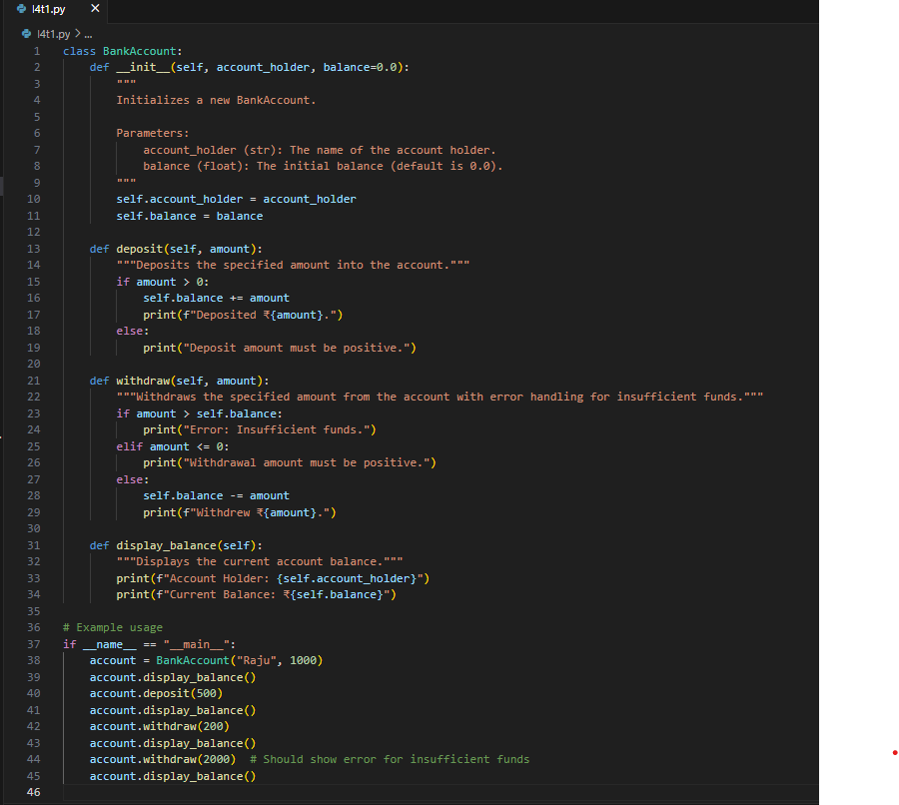

Output:

**Task 2:**

Description:

Auto-Complete a For Loop to Sum Even Numbers in a List

Write a comment and the initial line of a loop to iterate over a list. Allow GitHub Copilot to complete the logic to sum all even numbers in the list.

Prompt:

Write a comment and the initial line of a Python loop to iterate over a list, then let GitHub Copilot auto-complete the logic to sum all even numbers in the list and implement with example.

Code:

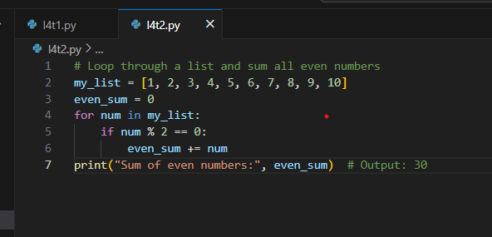

Output:

Task 3:

Description: Auto-Complete Conditional Logic to Check Age Group

Start a function that takes age as input and returns whether the person is a child, teenager,adult, or senior using if-elif-else. Use Copilot to complete the conditionals

Prompt: Generate a python function that takes age as input and returns whether the person is a child, teenager,adult, or senior using if-elif-else.implement with clear example.

Code:

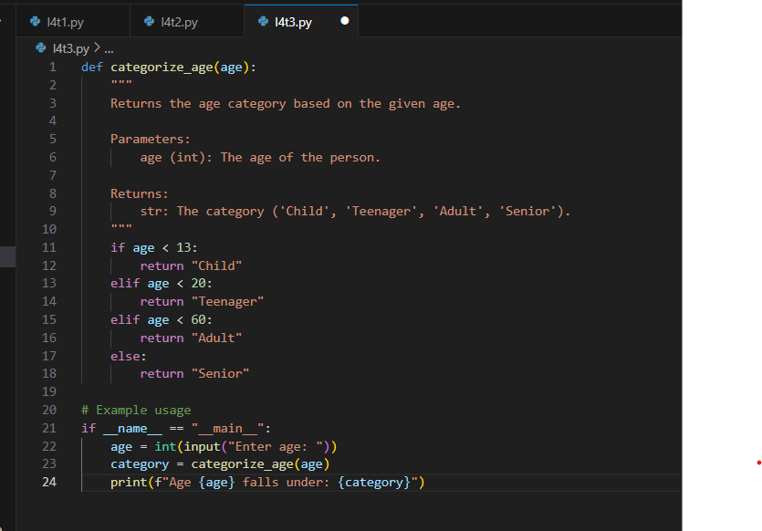

Output:

**Task 4:**

Description: Auto-Complete a While Loop to Reverse Digits of a Number

Write a comment and start a while loop to reverse the digits of a number. Let Copilot complete the loop logic.

Prompt: Generate a Python comment and start a while loop to reverse the digits of a number. Then use GitHub Copilot to auto-complete the loop logic and implement it with example

Code:

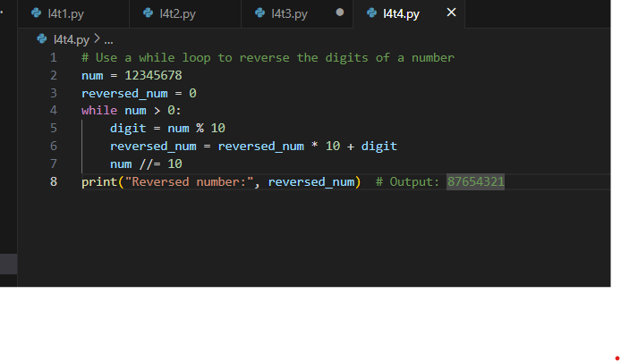

Output:



Task 5:

Description: Auto-Complete Class with Inheritance (Employee → Manager)

Begin a class Employee with attributes name and salary. Then, start a derived class Manager that inherits from Employee and adds a department. Let GitHub Copilot complete the methods and constructor chaining

Prompt:

Write the start of a Python class Employee with attributes name and salary, then begin a derived class Manager that inherits from Employee and adds a department attribute. Let GitHub Copilot auto-complete the constructors and any necessary methods, including proper constructor chaining implement with example.

Code:

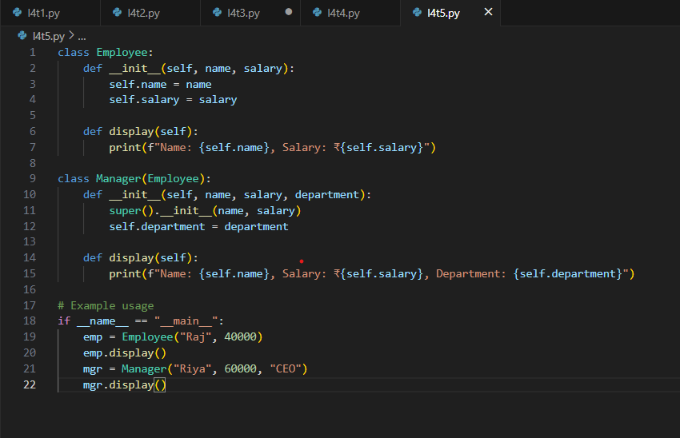

Output:

**Observation:**

I observed that **GitHub Copilot** can be effectively used to auto-complete Python code when given suitable prompts. By providing only the base structure such as a class definition, function header, or loop starter, Copilot was able to generate full implementations with a logical flow.

* **Task 1:** I found that Copilot could create a complete Python class with a constructor, methods, and error handling from just a descriptive prompt.
* **Task 2:** It was able to finish the loop logic to filter and sum even numbers, which shows its understanding of conditional iteration.
* **Task 3:** The age classification function demonstrated how Copilot manages nested conditionals and produces meaningful results.
* **Task 4:** The while loop for reversing digits highlighted Copilot’s ability to deal with mathematical logic inside loops.
* **Task 5:** I noticed that Copilot can also implement object-oriented concepts such as inheritance and constructor chaining efficiently.